Rozwijanie uczniowskich talentów
SZKOLNY KONKURS RECYTATORSKI

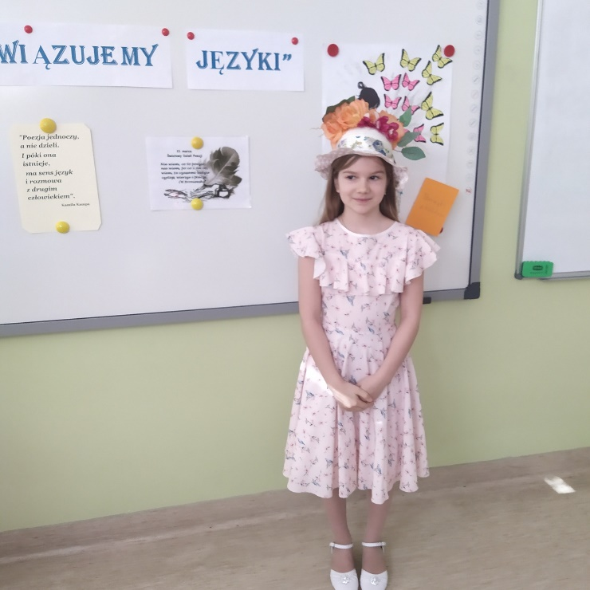
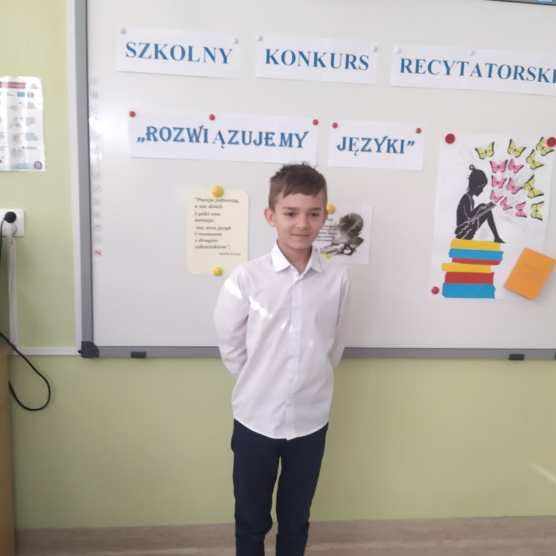

https://spborowa.edupage.org/news/?eqa=d2lkPW5ld3NfTmV3c18xX3AmbmV3c2FyY2hpdmVmPTIwMjEtMTAmb2Zmc2V0X25ld3NfTmV3c18xX3A9MjA%3D#photos:album:1553
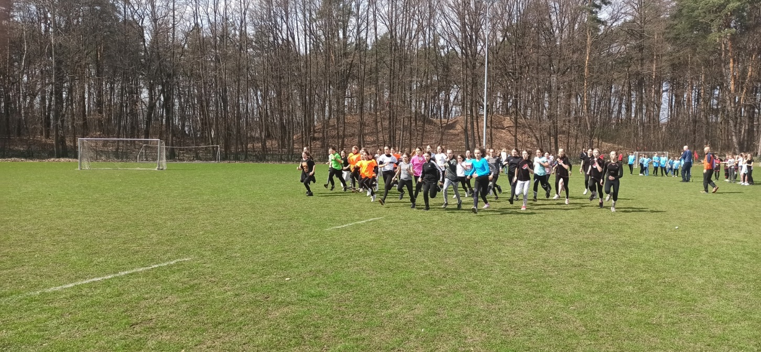
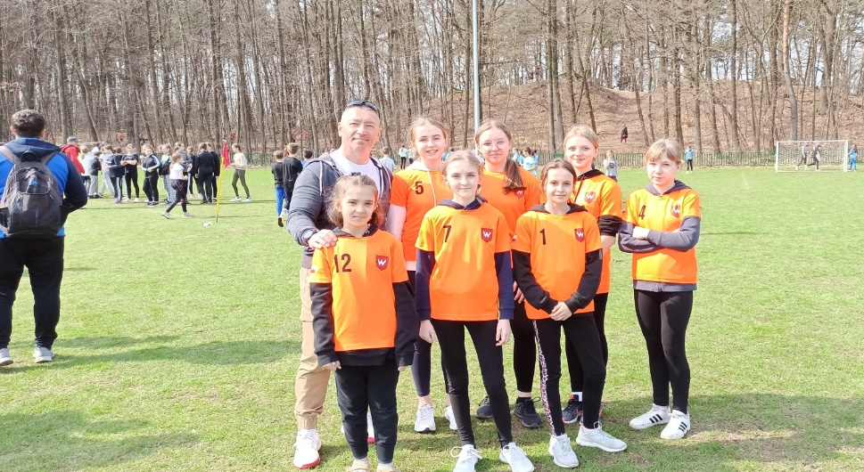
Dbanie o kondycję i aktywność fizyczną

REJONOWE ZAWODY W BIEGACH PRZEŁAJOWYCH
W KOLBUSZOWEJ

https://spborowa.edupage.org/news/#photos:album:1710
Kształtowanie postawy szacunku do historii
AKCJA SPOŁECZNO- EDUKACYJNA ,,ŻONKILE”

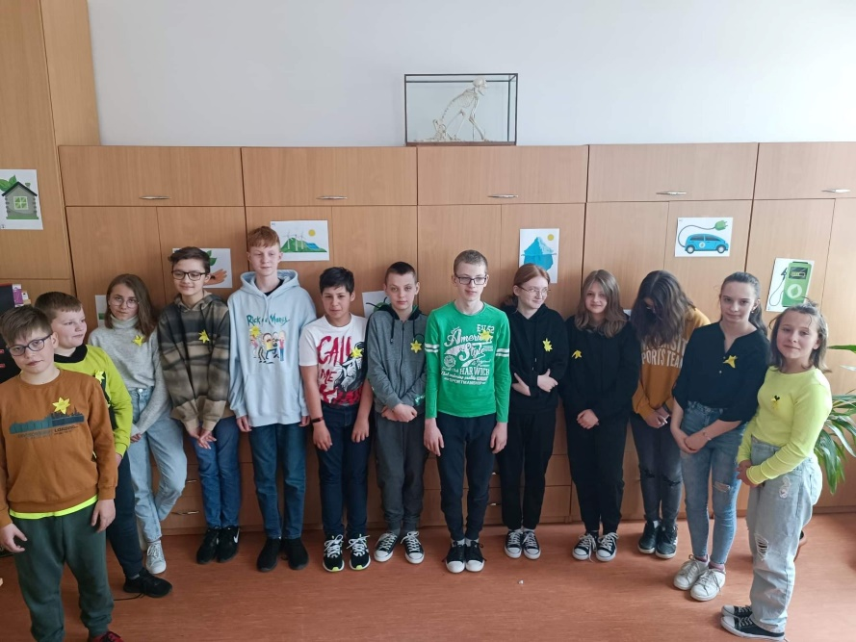
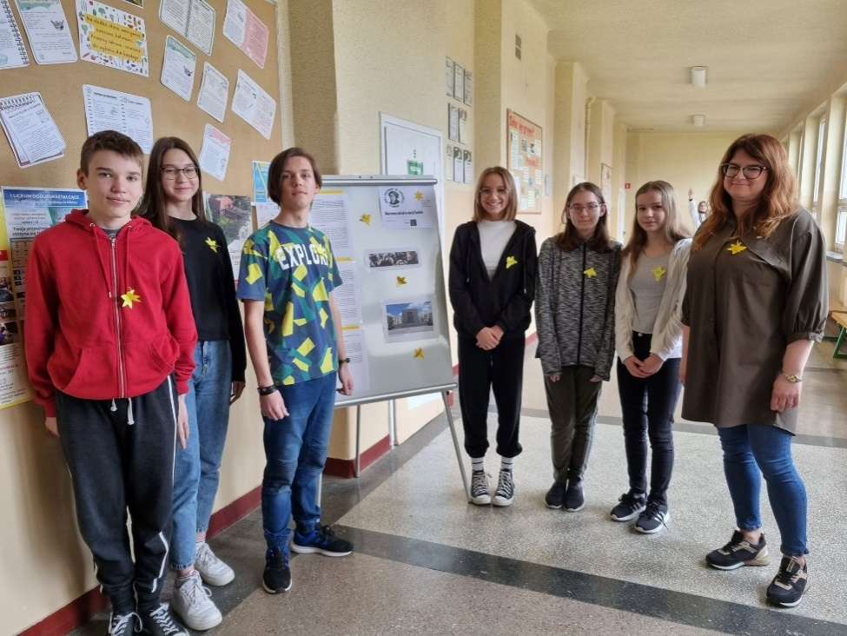

https://spborowa.edupage.org/news/?eqa=d2lkPW5ld3NfTmV3c18xX3AmbmV3c2FyY2hpdmVmPSZvZmZzZXRfbmV3c19OZXdzXzFfcD0w#photos:album:1726
Rozwijanie talentów
MIĘDZYNARODOWY DZIEŃ TEATRU

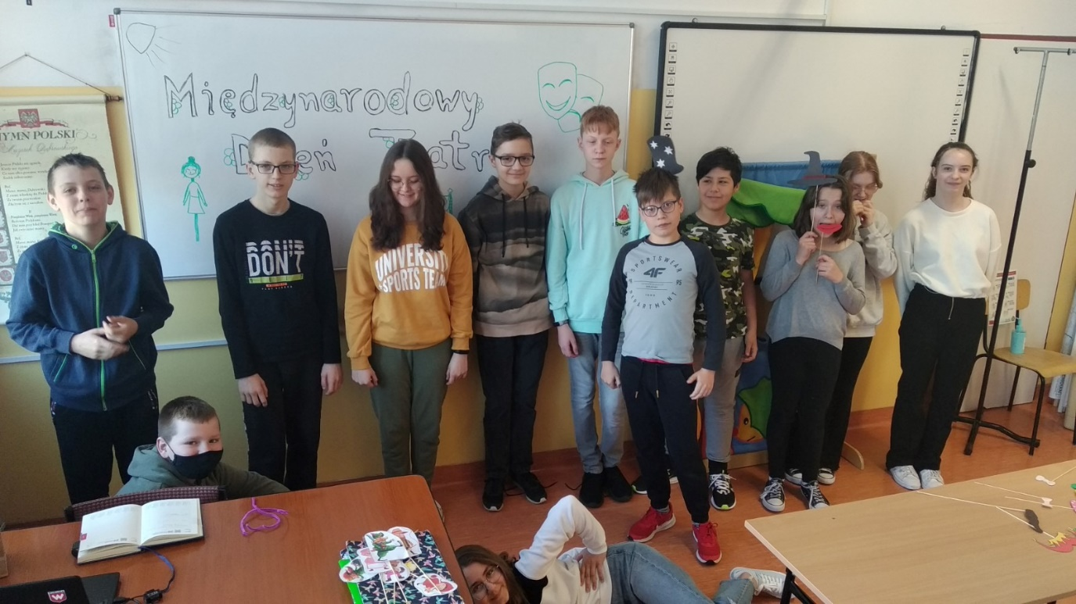
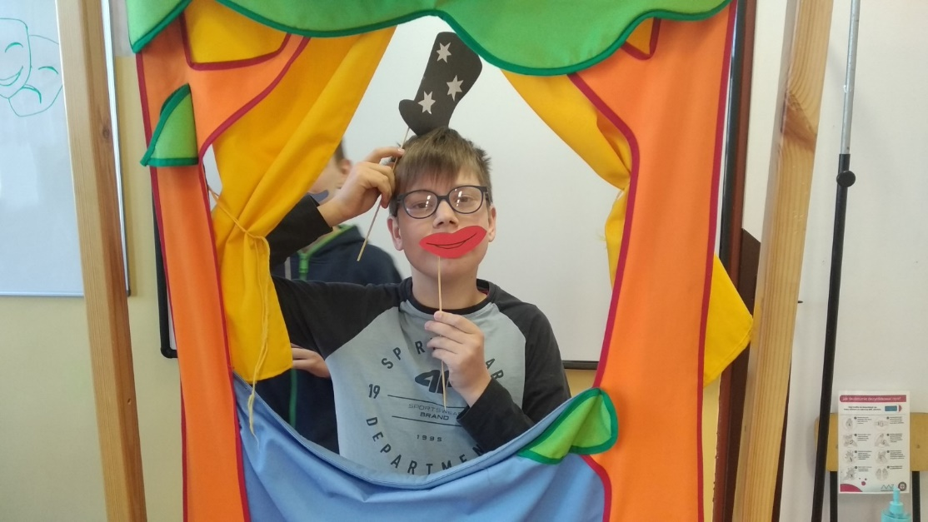

https://spborowa.edupage.org/news/?eqa=d2lkPW5ld3NfTmV3c18xX3AmbmV3c2FyY2hpdmVmPSZvZmZzZXRfbmV3c19OZXdzXzFfcD0yMA%3D%3D#photos:album:1708
Budowanie pozytywnych relacji rówieśniczych
STARSI CZYTAJĄ MŁODSZYM

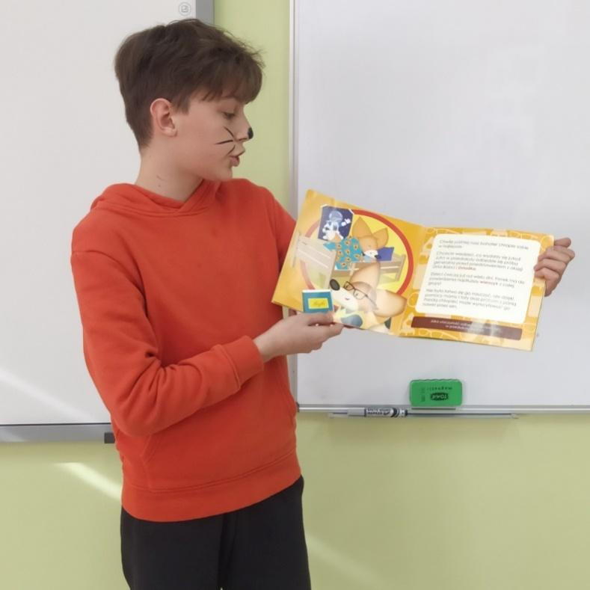
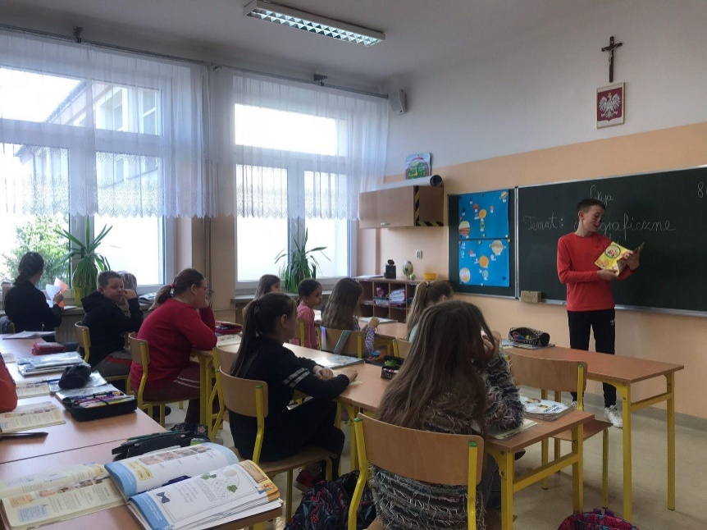

https://spborowa.edupage.org/news/#photos:album:1715
Promowanie czytelnictwa
SPOTKANIE Z CYKLU „STRAGAN Z KSIĄZKAMI”

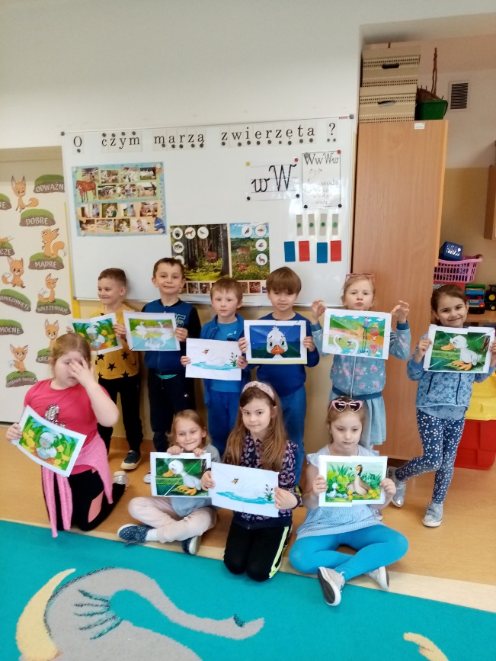
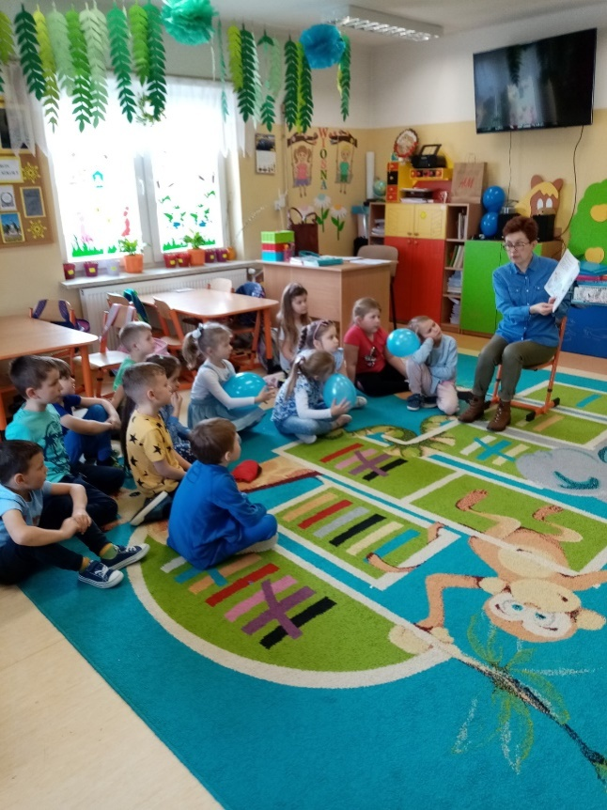

https://spborowa.edupage.org/news/?eqa=d2lkPW5ld3NfTmV3c18xX3AmbmV3c2FyY2hpdmVmPSZvZmZzZXRfbmV3c19OZXdzXzFfcD0yMA%3D%3D

Budowanie otwartego stosunku do ludzi
NA KOLOROWO DLA AUTYZMU

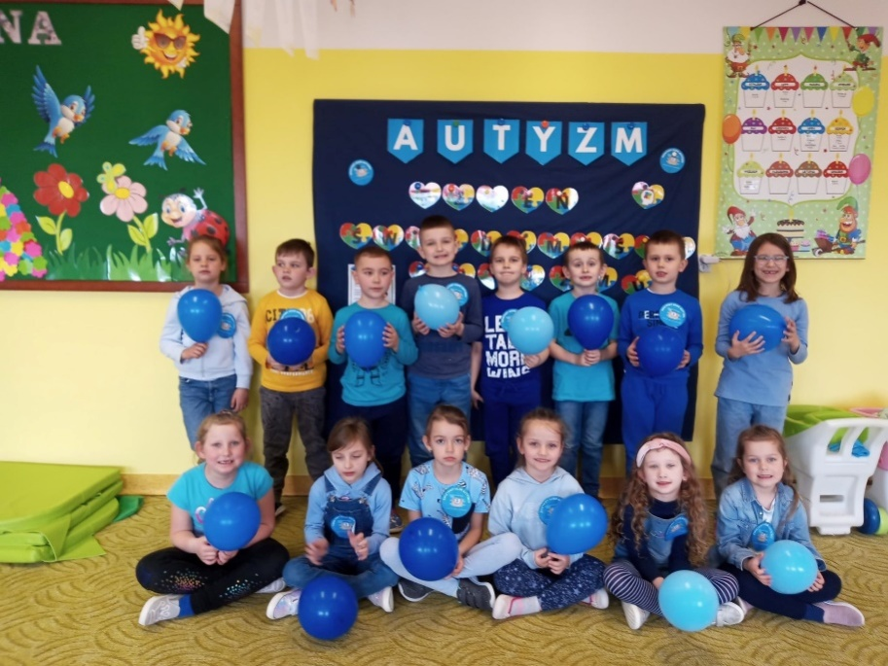
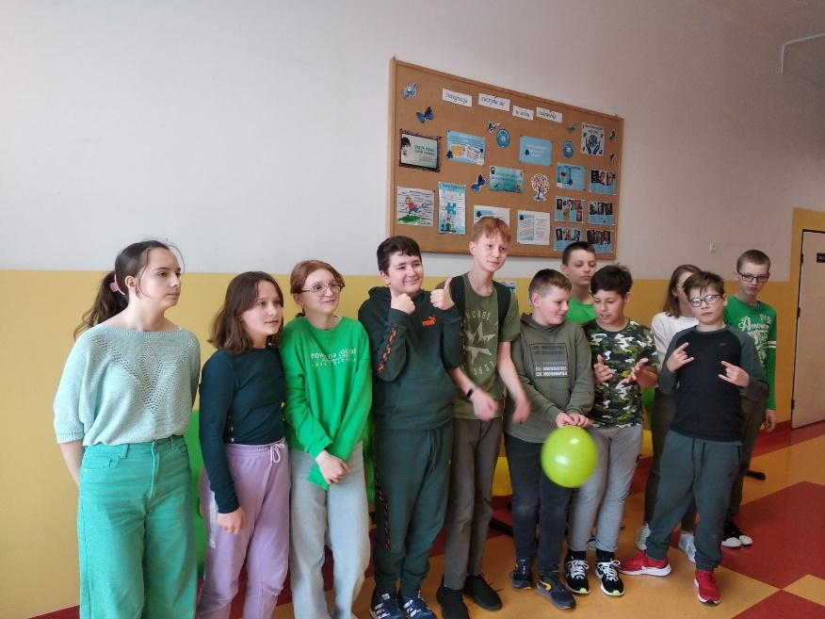

https://spborowa.edupage.org/news/?eqa=d2lkPW5ld3NfTmV3c18xX3AmbmV3c2FyY2hpdmVmPSZvZmZzZXRfbmV3c19OZXdzXzFfcD0yMA%3D%3D#
Rozbudzanie uczniowskiej kreatywności
GALA GRECKICH BOGÓW

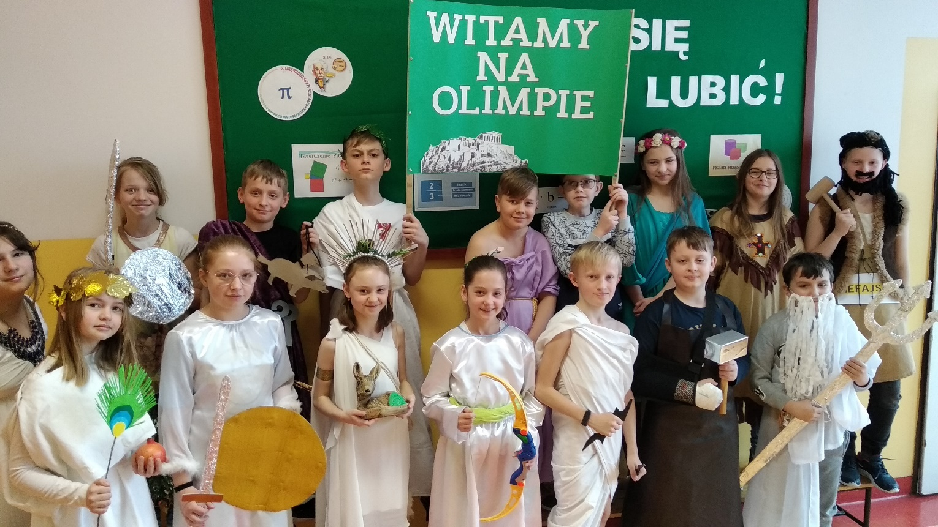

https://spborowa.edupage.org/news/?eqa=d2lkPW5ld3NfTmV3c18xX3AmbmV3c2FyY2hpdmVmPSZvZmZzZXRfbmV3c19OZXdzXzFfcD00MA%3D%3D#photos:album:1707
Współpraca z instytucjami
WIZYTA W OREW W WOLI PŁAWSKIEJ

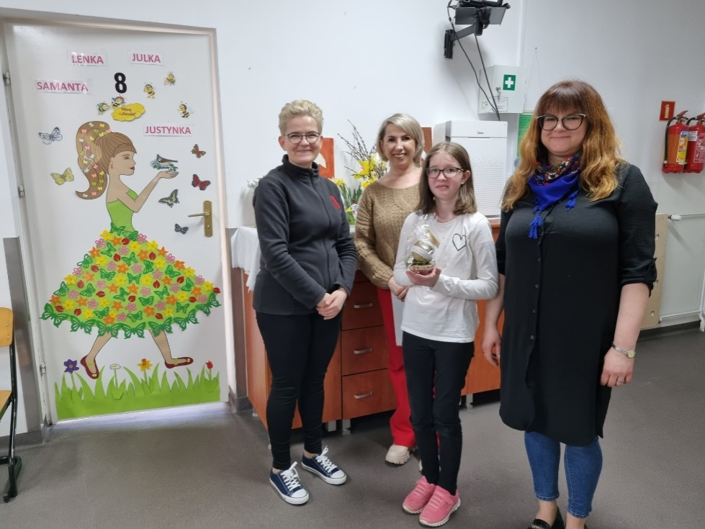
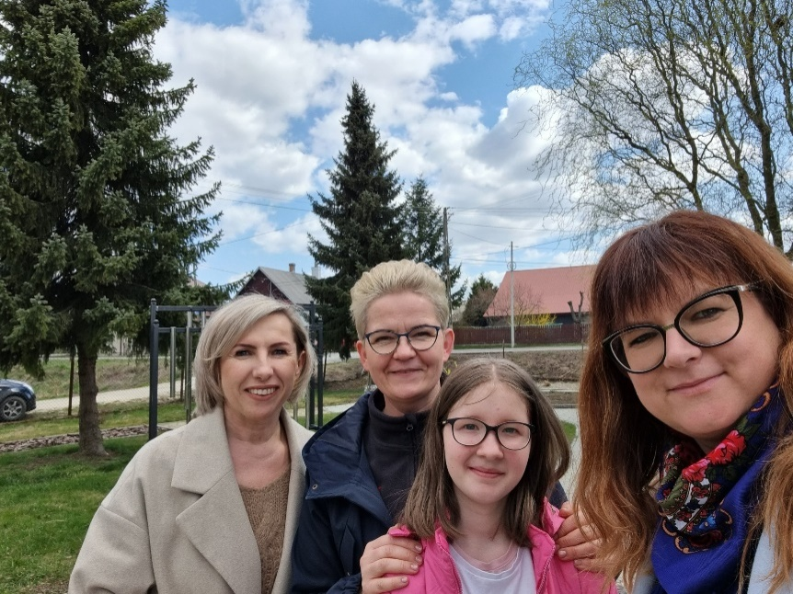
https://spborowa.edupage.org/news/?eqa=d2lkPW5ld3NfTmV3c18xX3AmbmV3c2FyY2hpdmVmPSZvZmZzZXRfbmV3c19OZXdzXzFfcD00MA%3D%3D#

